Lab 5

Analysis of a Cloud Provider

For this report I have chosen to analyze Microsoft Azure from a business perspective. Microsoft Azure is a cloud computing platform and infrastructure that was developed by Microsoft. It enables users to construct, deploy, and manage applications and services by utilizing a worldwide network of datacenters that are managed by Microsoft. PaaS and IaaS services are both provided by this platform, and it is compatible with a wide variety of programming languages, tools, and frameworks, including those developed by Microsoft as well as those developed by third parties.

1. Target Market

Published data [1] shows the market share of Microsoft Azure to be as follows:

When we break down who uses Microsoft Azure and where they work, we see that the retail sector (7%) and the IT and services sector (6%) are the most popular.

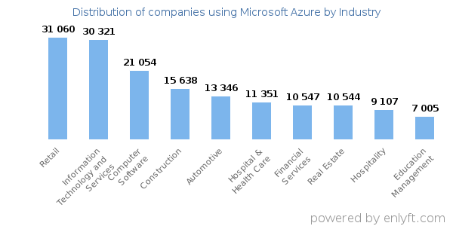

The United States accounts for 40% of Microsoft Azure customers, whereas the United Kingdom accounts for just 7%.

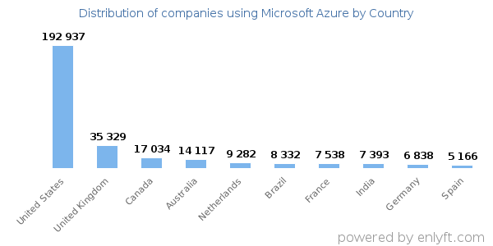

Microsoft Azure users can be roughly broken down into three categories: small (less than 50 employees), medium (51-999 employees), and large (1000+). The majority users are small vendors at 59%, medium vendors are next in terms of stake at 31% and large vendors make up 11% of Azure's user base.

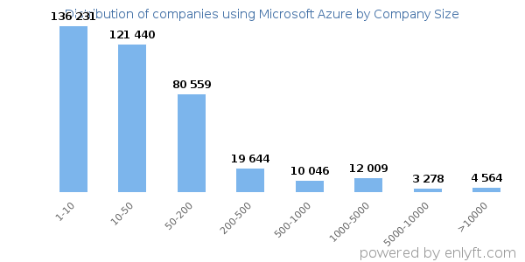

Classified by revenue, things start changing a bit. Seventy percent of Microsoft Azure users are classified as "small" (annual revenue $50 million), while fourteen percent are classified as "large" (annual revenue $1,000 million), and eight percent fall into the "medium" category (annual revenue $50 million to $1 billion).

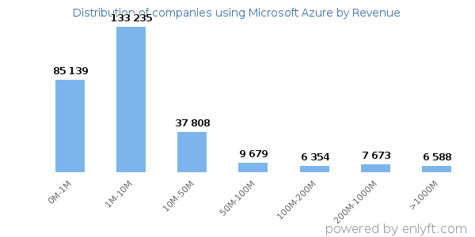

[2][3][4]Azure cloud services help businesses create, deploy, and manage complex apps quickly. Azure's competitors don't allow familiar languages, databases, frameworks, and operating systems. Azure is the best platform for SMBs looking to maintain basic IT services like Active Directory (AD), Domain Name System (DNS), network security, and the development and deployment of advanced business apps. Due to its advantages and ease of integration, Microsoft Azure is the best option for managed services. Azure's PaaS model can extend your network, or Microsoft can handle all your computing and networking needs with IaaS. Both methods provide secure access to cloud-based programs and data. Azure offers a variety of software and services to meet your needs.

1. Competitive Market

[5][6]Google Cloud Platform, Amazon’s AWS, IBM Cloud, Oracle Cloud, VMware Cloud, Dell Technologies Cloud, and Alibaba Cloud are among Azure's main rivals. Amazon Web Services (AWS) is Microsoft Azure's main rival. GCP is Azure's second challenger. GCP is a newcomer, therefore it offers fewer services and has fewer data centers than AWS and Azure.

Benefits of Microsoft Azure:

* PaaS and IaaS:

IaaS and PaaS give Azure an edge. IaaS enables companies outsource their infrastructure to Azure and pay for what they use, and PaaS lets them build their own apps and solutions without buying and managing the framework. Cloudaeon develops apps and solutions utilizing Azure's PaaS and IaaS.

* Excellent Hybrid Capabilities

Azure is a mobile, consistent on-premises and Cloud platform. VPNs, CDNs, caches, and ExpressRoute connections increase Azure's usability, availability, and speed.

* Minimized development costs and time

Enterprises may quickly construct a DevOps infrastructure and CI/CD pipeline to speed development. Development, testing, integration, and delivery can happen in one environment.

* Industry-standard security

o Azure's multilevel security protects data in remote data centers. Strong passwords, multi-factor authentication, and threat training secure user data. Azure's Security Center uses machine learning to detect threats.

* Enhanced flexibility and scalability

o Azure allows one-click service level upgrades and decreases. Use-based pricing. Open-source Azure. Azure supports languages and frameworks. Developers can build apps in their preferred ecosystems.

1. Business Model [7][11][12]

* Value Creation:

Azure creates value through the following:

* + Platform for business growth based on faster time to market
  + Resiliency, disaster recovery, strong security
  + Efficiencies allow for greater focus on project work
  + Serverless capabilities drive improved security
  + Faster time to market through faster access to compute/storage capacity
* Value Capture:

As a component of Microsoft's Server Products and Cloud Services division, Azure is a clear source of the company's rising profits. As both a crucial component of Microsoft's infrastructure and a major source of income, Azure has become the company's beating heart.

In 2022, revenue from Azure Cloud Services increased by 45% to $44 billion (excluding Server Products). Because of this, next year Azure will almost certainly bring in more money than Office, Microsoft's traditional cash cow.

1. Performance

[8][9]One-third of all money spent on cloud infrastructure services in the second quarter of 2022 went to Amazon Web Services (AWS), making it the dominant cloud service provider. With a 24% market share, Microsoft Azure was the second largest cloud service provider. Only 8% of the market was made up by Google Cloud.

Microsoft's fiscal first-quarter results were barely ahead of analyst forecasts.

The period's revenue of $50.1 billion surpassed analysts' forecasts of $49.66 billion by a wide margin. Microsoft's first fiscal quarter brought in a total of $17.56 billion in earnings. The profits were much better than expected but overall growth has slowed down.

1. Future Prospects

[10]Every company has a future in the cloud space as all the products in the world are becoming subscription-based services and grow to global markets. The public cloud industry is expected to reach a value of $397.4 billion by 2022, according to research from recognized source Gartner. Consumer expenditure on public cloud services is predicted to rise to $494.7 billion in 2022, up 23% from the projected total of $410.9 billion in 2021. By 2023, it is anticipated that end-user spending on the public cloud would have reached about $600 billion USD.

It is estimated that by 2022, IaaS (Infrastructure as a service) would have one of the greatest end-user spending growths at 30.6%. The use of DaaS (Desktop as a Service) will increase by 26.6%, and that of PaaS (Platform as a Service) will increase by 26.1%. (Platform as a Service).

The rising prevalence of hybrid work models presents a barrier to the widespread adoption of cloud computing's conventional workforce model, in which PCs and other physical office tools were the norm. Their move to DaaS could result in an additional $2.6 billion in costs.

SaaS is projected to become the largest public cloud services market by 2022, with a value of $176.6 billion by that year.

References:

[1] https://enlyft.com/tech/products/microsoft-azure

[2] https://customers.microsoft.com/en-us/story/862791-loreal-retailers-azure

[3] https://www.contino.io/insights/whos-using-microsoft-azure-2020

[4] https://www.crn.com/news/cloud/top-cloud-market-share-leaders-aws-microsoft-google-lead-q2-2022?itc=refresh

[5] https://www.cloudaeon.co.uk/blog/microsoft-azure-competitors-comparison-advantages

[6] https://www.techtarget.com/searchcloudcomputing/definition/Windows-Azure

[7] https://azure.microsoft.com/en-us/resources/idc-white-paper-the-business-value-of-microsoft-azure-for-sql-server-and-windows-server-workloads/

[8] https://azure.microsoft.com/en-us/blog/azure-cloud-business-value-for-retail-and-consumer-goods-explained/

[9] https://www.capacitymedia.com/article/2afswwuvis94wy12r320w/news/google-cloud-growing-45-a-year-with-azure-at-40-says-canalys

[10] https://news.microsoft.com/2022/10/25/microsoft-cloud-strength-drives-first-quarter-results-5/

[11] https://www.kamilfranek.com/how-microsoft-makes-money-business-model-explained/#-microsofts-revenue-breakdown-into-streams

[12] https://www.kamilfranek.com/microsoft-financial-statements-overview-and-analysis/